Drawing progression

Typical progression | How to support development
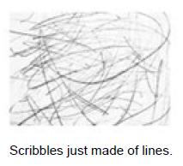 | Practitioners have a crucial role to play in supporting  children's drawing experiences. They need to:  ● Plan meaningful activities and experiences that  build on the children's knowledge, understanding  and interests  ● Have a good grasp of child development in relation  to early mark-making in order to plan suitable  experiences.  ● Provide children with open-ended opportunities to  try out different resources in different environments  ● Introduce new media and different ways of using  known media  ● Allow the children the time and space to immerse  themselves in these experiences  ● Value children's individual creativity.  To create an enabling environment in which children's drawing  can flourish, settings should aim to provide:  ● Opportunities both indoors and outside, with the  provision of free flow between both environments  wherever possible. Many children, especially boys, often  make greater use of drawing and mark-making  opportunities outside where they can engage using  large-scale whole-body movements.  ● A range of resources and materials to facilitate  mark-marking opportunities.  ● A wide range and variety of materials and surfaces from  which children can choose, as self-selection is important  to young children's learning. These can conventional  drawing tools of different widths (from thin charcoal  sticks to fat coloured chalks) and natural materials like  twigs and branches, and conventional materials, from  paper and card to light boxes and sand from a beach.


