Cutting with scissors progression

Typical progression | How to support development
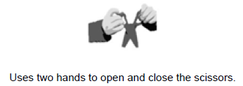 | ● Practise tearing paper  ● Strengthen fingers – use soft balls, playdough, toys filled with beans/sand  ● Practise opening and closing blades on  Playdough scissors, in the sand or shaving foam, progressing to more firm materials like  modelling clay.  ● Encourage ‘thumbs up’ position  ● Practise snipping, using foam sheet sat first, to practice holding paper and snipping one handed.  ● Progress to thicker paper, e.g. sugar paper for easier handling.  ● You could draw straight lines on the foam to introduce the idea of going forward, if ready.  ● Practise activities to promote crossing the  mid-line of the body e.g. passing a ball from left to right, or filling up a pot on the left with the toys placed on the right.  ● Promote activities to strengthen bilateral  coordination e.g. lacing cards, holding a stencil with one hand and drawing with another, hand clapping games.


