Writing progression

Early mark making
Preliterate mark making
Children make marks because they realise they can.
It often forms part of their early appreciation of
cause and effect. (I can hold this chalk in my hand
and, when it touches another surface, then it leaves
a mark).
The marks don’t usually carry intentional meaning.
As the child has a palmar supinate grasp and is
pivoting from the shoulder, probably with a stiff
elbow and wrist, their marks go up and down,
horizontally and vertically, as well as round in large
circles or in a forwards or backwards ark.

Mark making for meaning  Shapes in mark making become more varied and  diverse.  Simplistic drawings emerge.  Children begin to make the connection between  print/drawings within the environment around them  and the fact that those symbols that they see carry  meaning. | 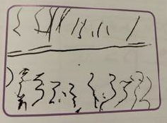
Directional mark making  Even though their marks may bear no resemblance  to recognisable letter shapes, some children will  make marks in the direction that print has been read  to them or written in front of them. | 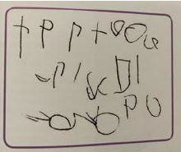
Symbolic mark making  Children produce some symbols that look like the  ones that they see in print around them. More than  likely they are not linking letter shapes to sounds;  rather are attempting to record what they see. | 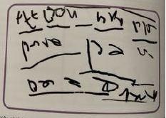
Emergent writing
Emergent writing  Children begin to record symbols because they know the sounds they make. They can also produce strings of letters. The children won’t necessarily understand the sounds of all the letters, but they understand some (often the ones related to their own name). The others they will record because they know that they are print and carry meaning. | 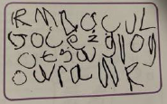
Copy Writers/Environmental writers  Children might be able to write their name. They might know it is their name and that it is ‘writing’; but they don’t know any of the sounds that are attached to the letter shapes. They are copy writers.  Some children copy down environmental print. This is because they know that it is ‘writing’ and they want to be ‘writers’. However they are not yet able to recognise the individual and groups of sounds that they see. They are environmental writers. | 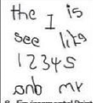
Initial sound in words  Children begin to hear and write initial sounds in words once their phonic knowledge enables them to do so. | 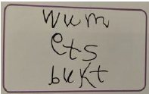
End sound in words
As children’s phonic knowledge builds and they develop their ability to hear sounds within words and not just at the beginning, you begin to see clusters of letters that record the initial and end
sound in words.

Medial sound in words
As children’s understanding develops further, you will begin to see attempts at medial sounds. Medial sounds are not only difficult to hear in words, they are often the most difficult to record, as they have unique spelling rules.

Transitional writing  The children have learnt a combination of letters can make one sound, e.g.sh, igh. ‘Special friends’ appear. Children begin to write phrases. | 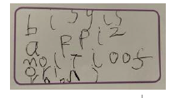
Sentence writing  Constructs a short sentence.  Some upper and lower case letters are used.  Punctuation is beginning to appear. | 

