Pencil grip progression

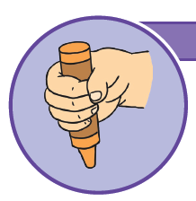 | Palmer supinate grip  Also referred to as the ‘Fisted Grip’.  The pencil is held in the palm with a whole fist and all of the fingers and thumb are used.  The movement comes from the child’s shoulder.  The elbow, wrists and fingers stay in a fixed position.  Light scribbles are produced with this grip.
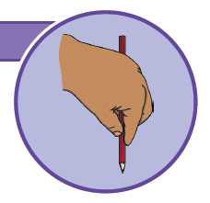 | Digital pronate grip  All fingers are holding the pencil.  - The wrist is turned so the palm is facing downwards, towards the page.  - The pointer finger, the ‘digit’, points to the tip of the mark-making tool.  - Most of the movement comes from the elbow.  - Horizontal, vertical and circular lines can be copied with this grip.
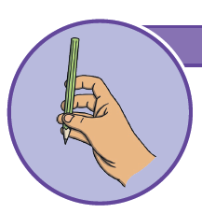 | Splayed four-finger grip  - The four fingers are held on the pencil, opposite the thumb.  - An arch is beginning to form between the thumb and the index finger.  - Movement is coming from the wrist.  - Hand and fingers move together.  - Zigzag lines, crossed lines and simple representations of people can be drawn with this grip.
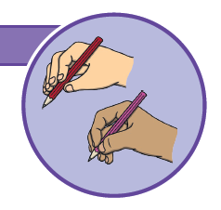 | Static tripod and quadropod grip  A static tripod grip is a three-finger grip. The thumb, index finger and middle finger work as one unit.  A static quadropod grip is when a fourth finger is part of the grip.  Movement is coming from the wrist.  Simple shapes, such as triangles, circles and squares, can be copied using this grip.
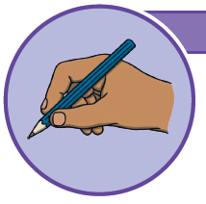 | Dynamic tripod grip  The thumb, index and middle finger hold the pencil in a stable position.  The ring and little fingers are bent and rest on the table, helping to stabilise the hand.  The index finger and thumb form an open space.  Dynamic movement is coming from the fingertips.  The pencil can be used accurately and efficiently and letters can be formed correctly using this grip.

